COMP 2019 Workbook Exercises Week 1 – Uninformed SearchSpecify in which order the states of the following graph would be expanded under each of the  
specified search strategies, starting in state A. Assume states are expanded in alphabetical order if  
there are multiple states to choose by the algorithm. The edge labels denote the true costs of  
moving between adjacent states. The goal is to find a path to state L.

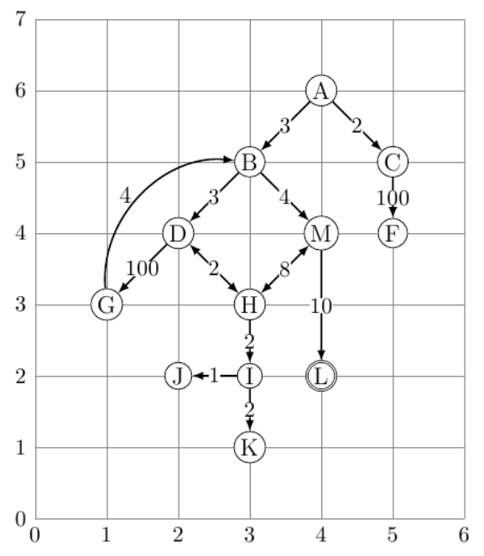

1) Which path from A to L will Breadth-First Search find first? ABC DMF GH L   
2) Which path from A to L will Uniform Cost Search find first? AC BDMH IJKL  
3) Which path from A to L will Depth-First Search find first? ABDG HIJK ML  
4) Which path from A to L will Iterative Deepening Depth-First Search find first? ABDG H MHL

I have question about the Workbook Exercise as it a cost of 26 for the DFS while it is only 17 (best path) for the others. Does it mean that the DFS not work or it just depends on how the algorithm works to find the path to the destination?